1. **Testing Your Personal Web Space on the CSBS Content Server:**

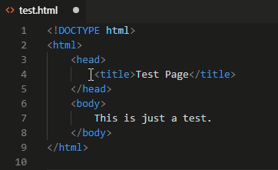

1. **View Your Test Page in a Browser:**

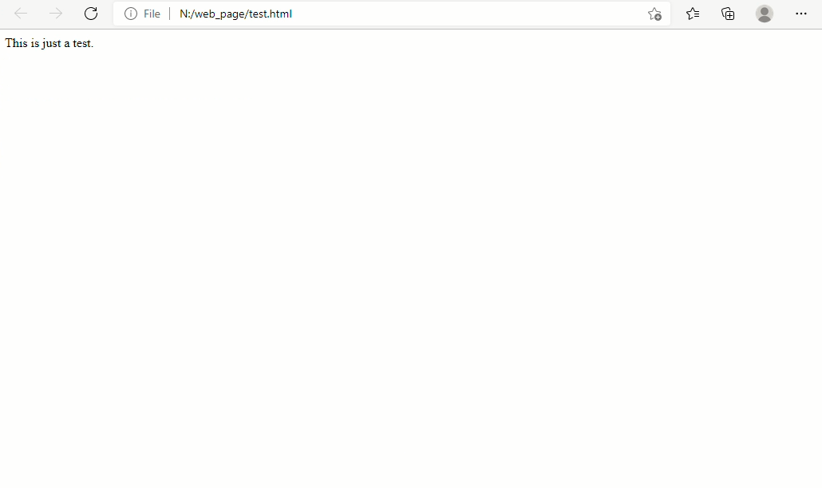

1. **Building Your First Web GIS Application:**

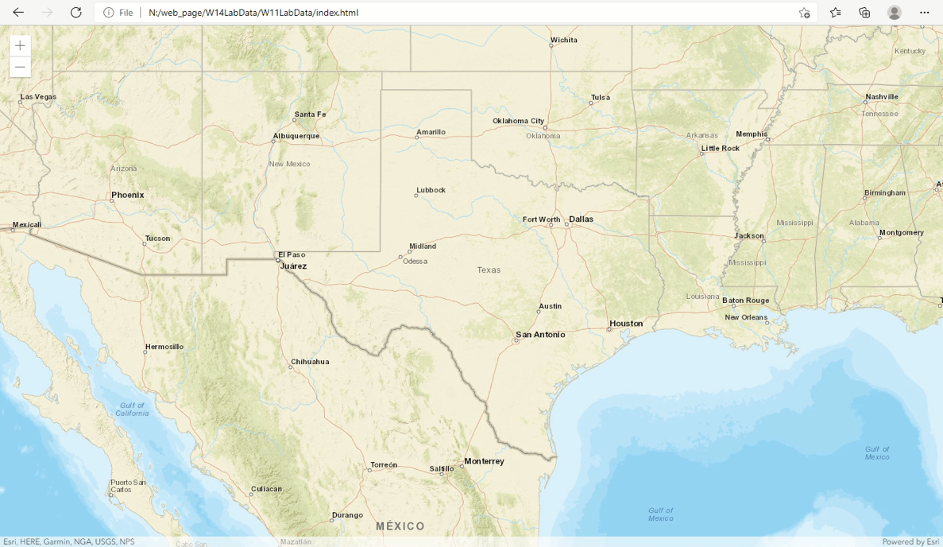

**“satellite” basemap:**

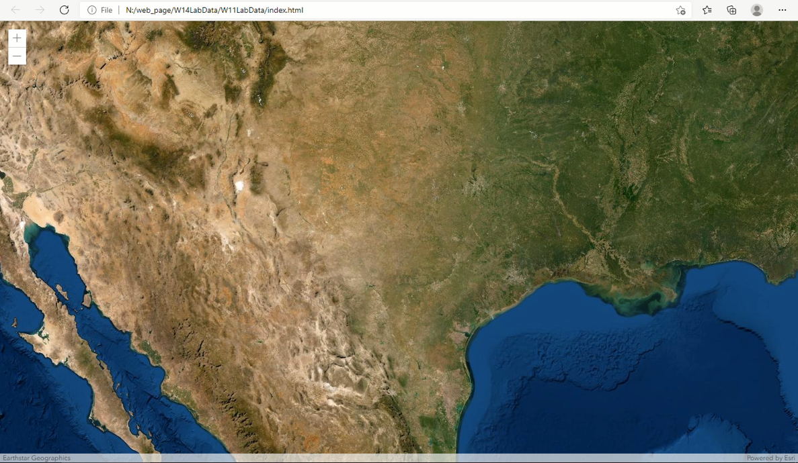

**“hybrid” basemap:**

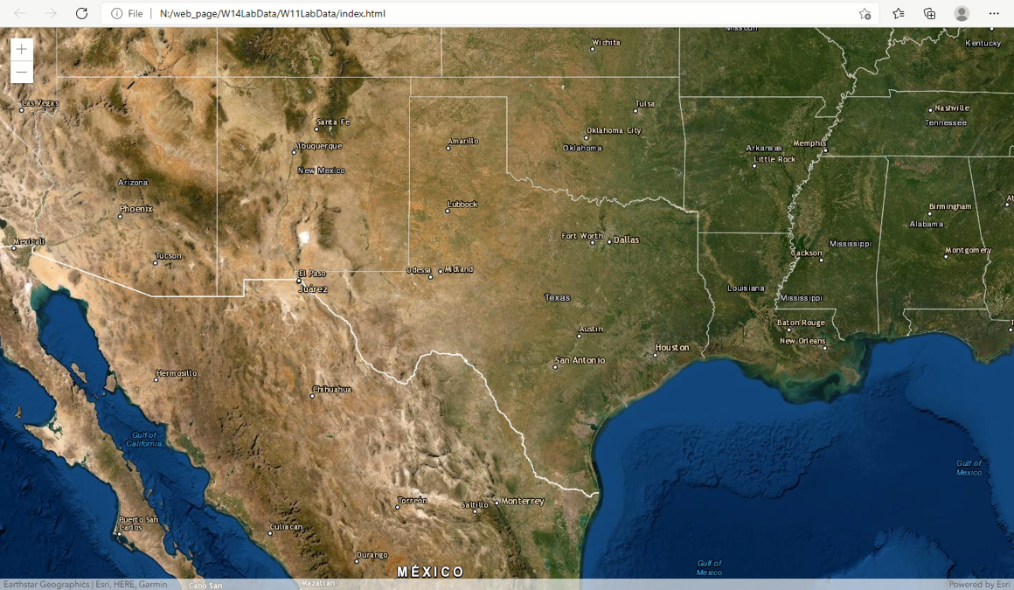

**“topo” basemap:**

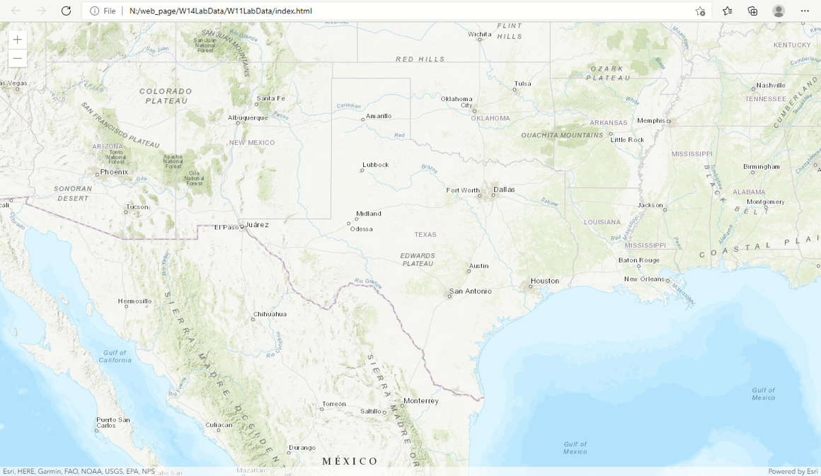

**SCALEBAR:**

**Code:**

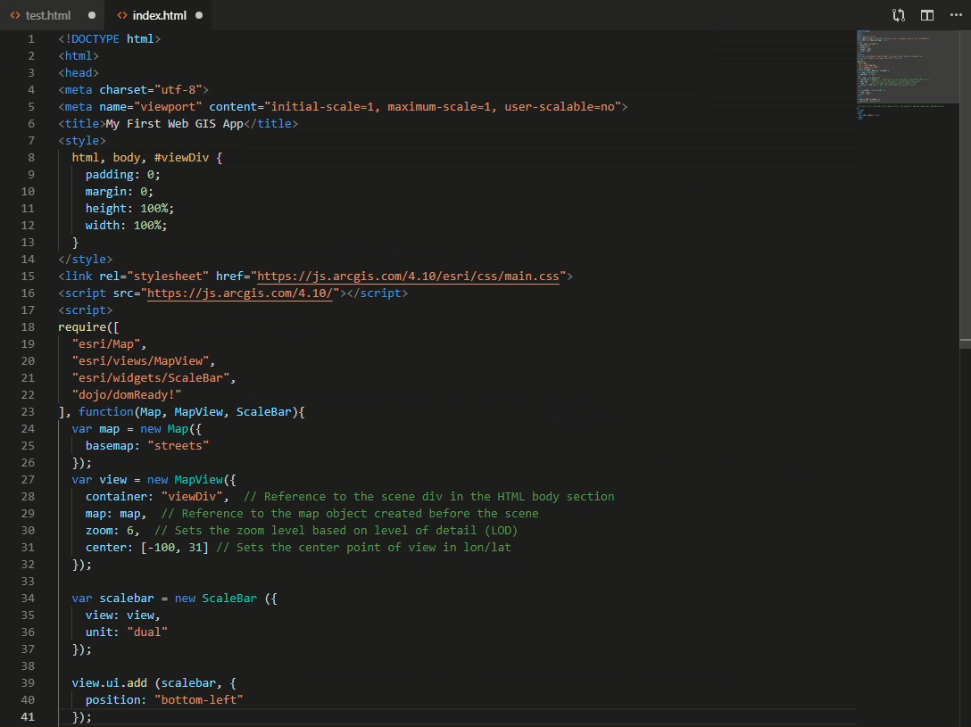

**Browser:**

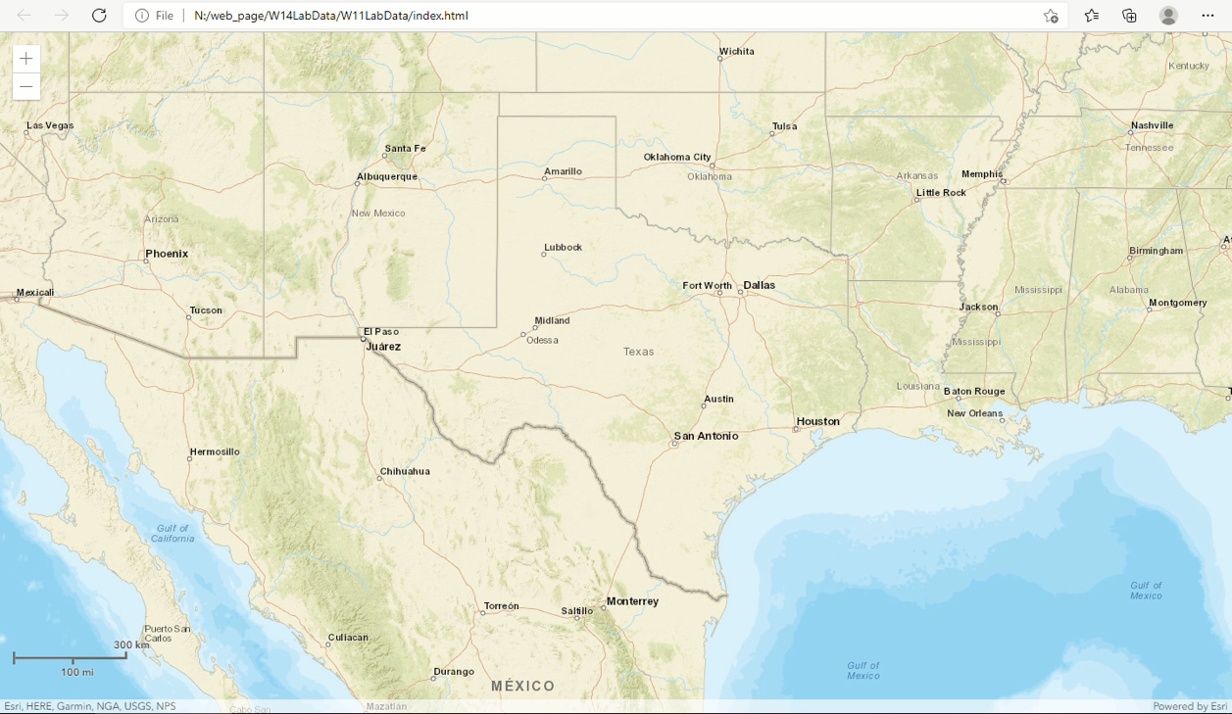

**FEATURE LAYER:**

**Code:**

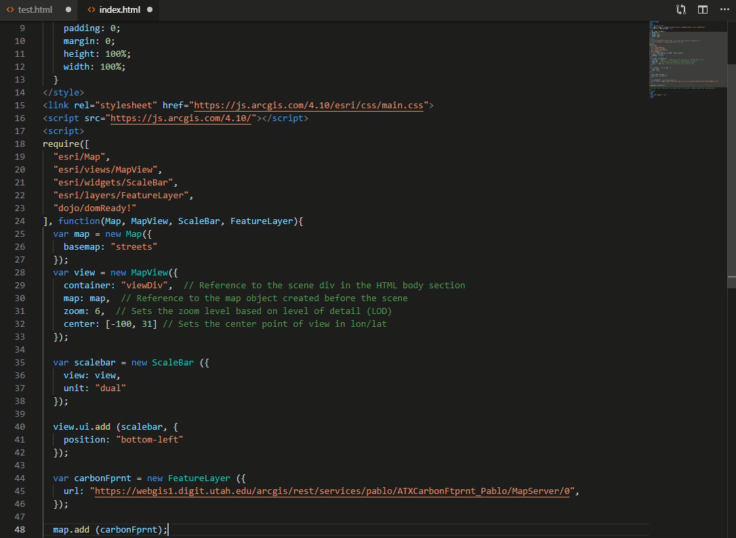

**Browser:**

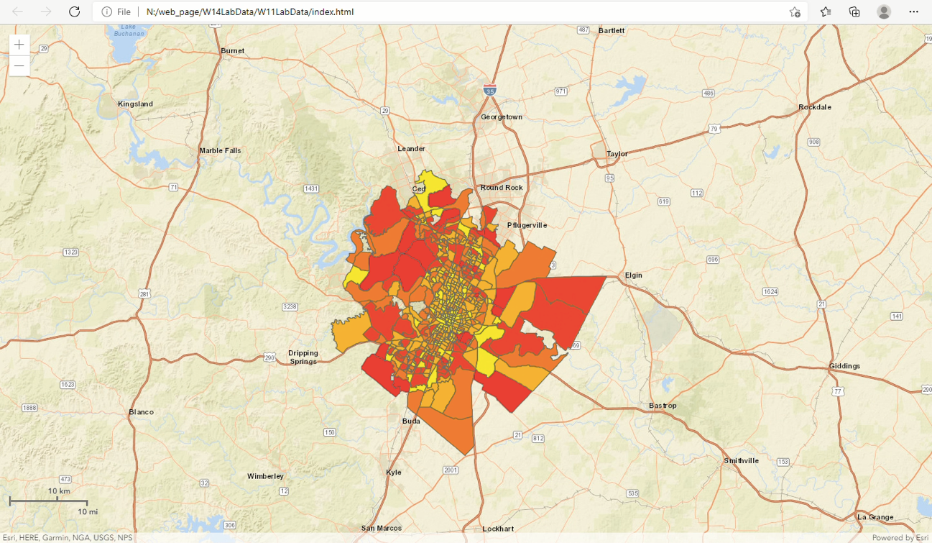

1. **Adding a Legend with Two Layers:**

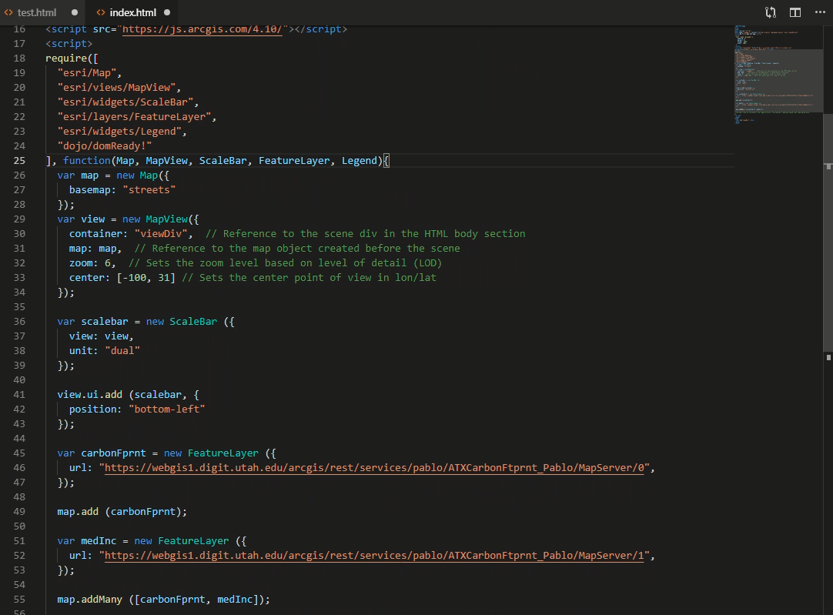

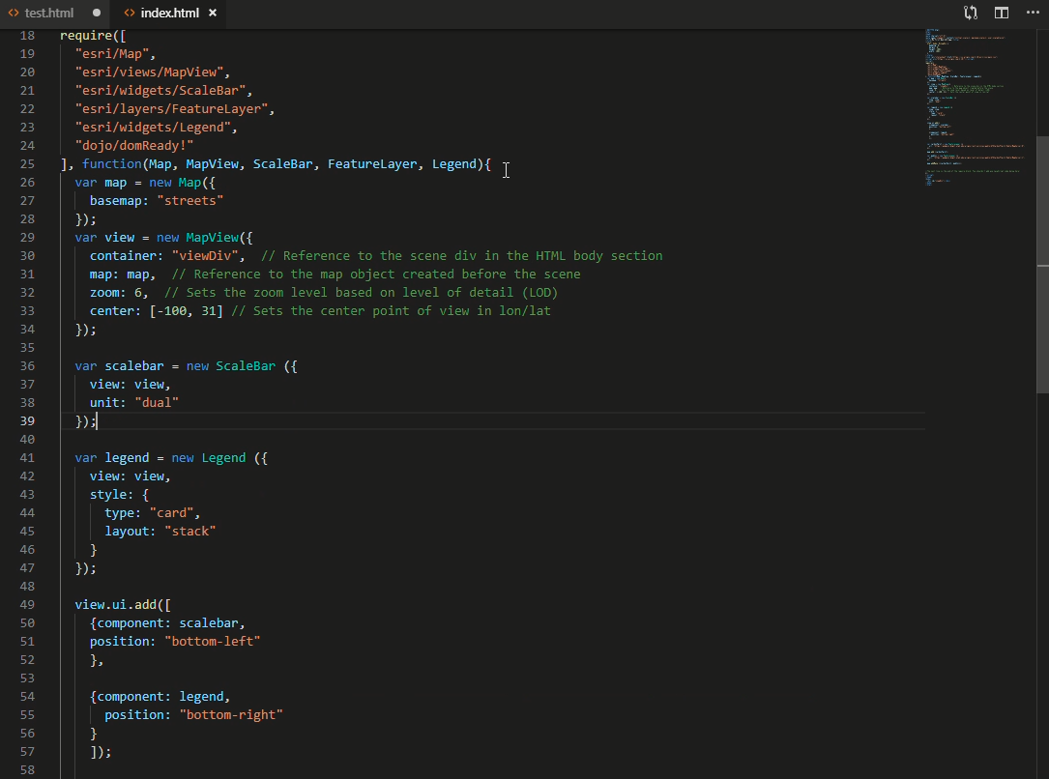

**What other built-in style types are there for the legend widget?**

* **classic, card**

**What are the other style layouts?**

* **auto, side-by-side, stack**

1. **View Your New Map in a Browser:**

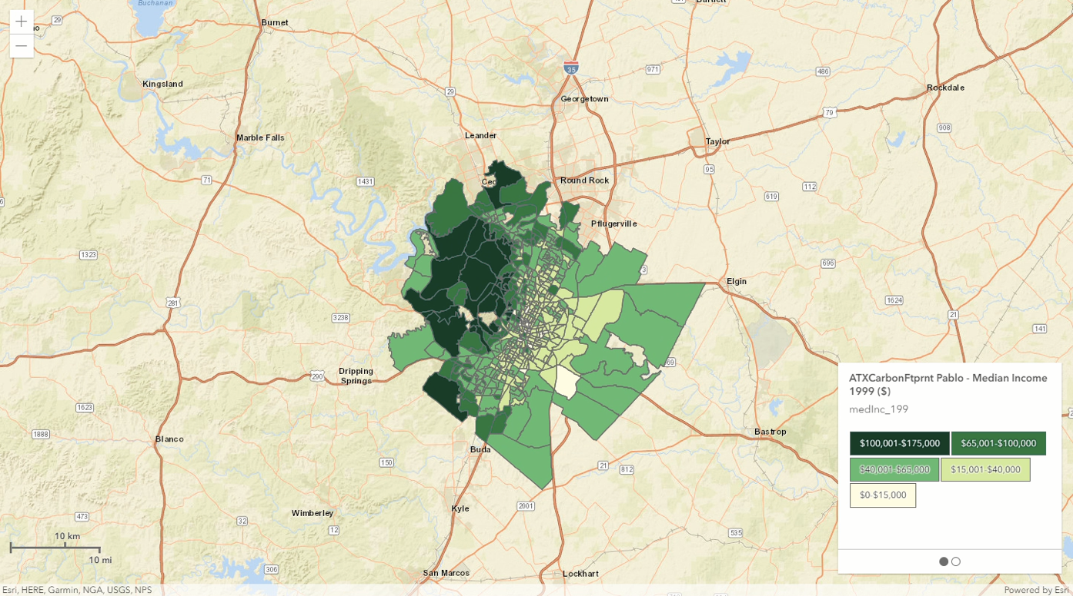

1. **Adding a LayerList Widget:**

**Code:**

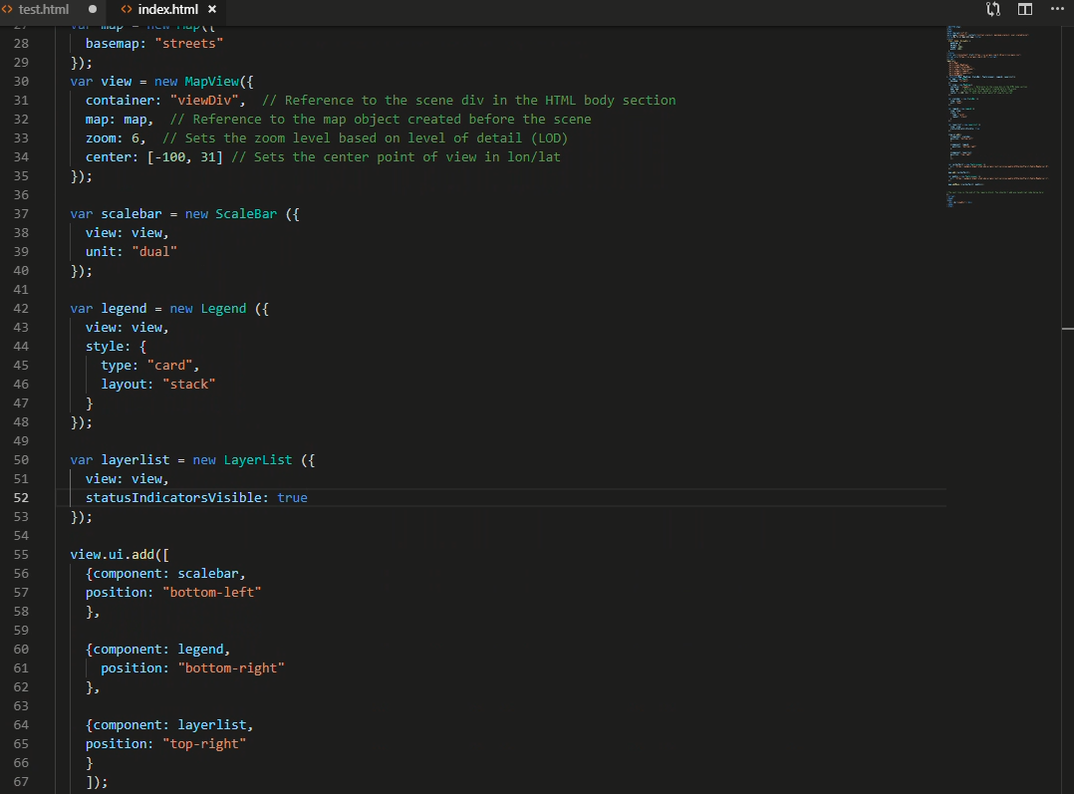

**Browser:**

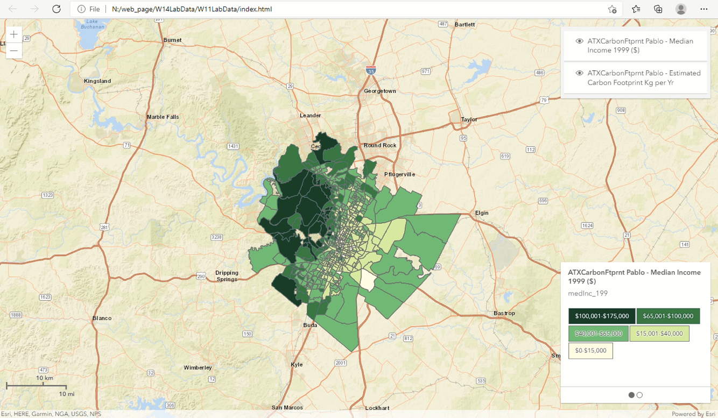

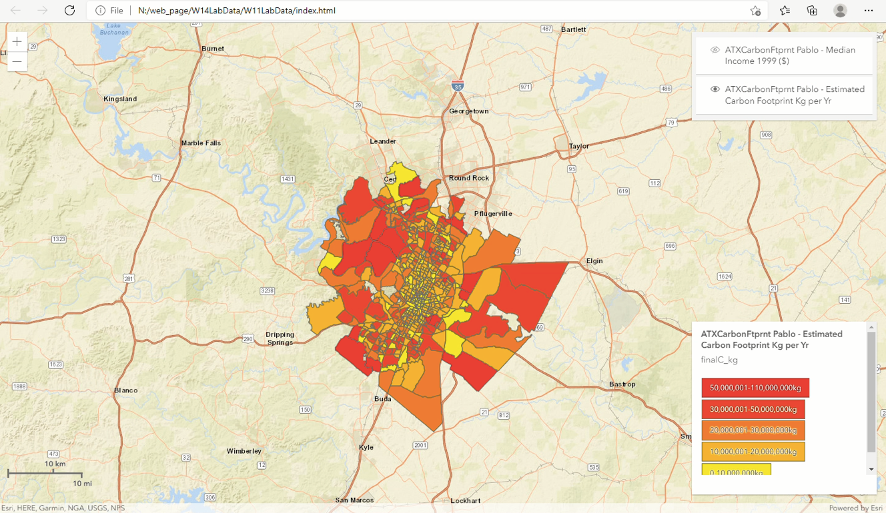

1. **Adding a Basemap Toggle:**

**Code:**

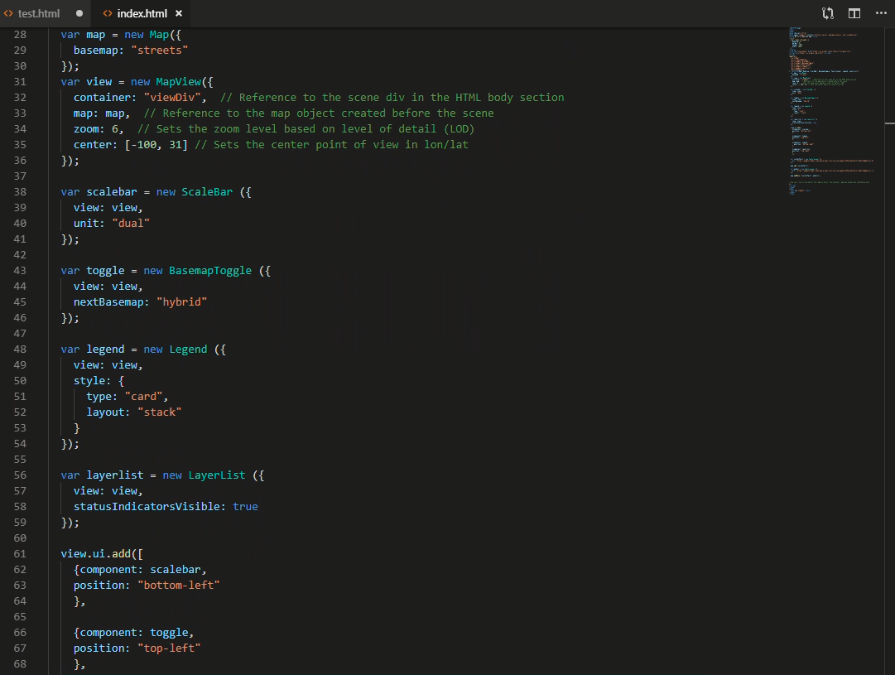

**Browser:**

